Weather Prediction System Using Artificial Neural Networks
Submitted by:
Samarth Verma
2305483
KIIT University
Course: Machine Learning(CS31002)
Date: January 2026

Table of Contents
- Abstract
- Introduction
- Problem Statement and Objectives
- Methodology and System Design
- 4.1 Dataset and Preprocessing
- 4.2 Feature Selection
- 4.3 Neural Network Architecture
- 4.4 Model Training and Optimization
- Implementation Details
- 5.1 Data Cleaning (clean_dataset.py)
- 5.2 Model Training (train_model.py)
- 5.3 Streamlit Web Application (app.py)
- Evaluation and Results
- Conclusion
- References
- Appendix (Generated Diagrams + Code Highlights)

Abstract

This project report presents the design and implementation of a Weather Prediction System that utilizes artificial neural networks (ANNs) to forecast next-day temperature based on multiple meteorological factors. The system, developed using TensorFlow and Keras, employs a multi-layer perceptron model trained on synthetic weather data. The proposed model demonstrates the potential of machine learning to learn complex relationships among temperature, humidity, pressure, and wind speed. The model is integrated into a Streamlit-based web interface for real-time prediction, thereby combining data science and practical application.
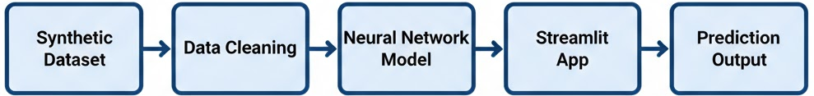
System Overview Diagram

Introduction

Weather prediction is a long-standing challenge due to the dynamic and nonlinear nature of atmospheric conditions. Traditional methods rely on numerical weather prediction models, which require vast computational resources and are sensitive to small input errors.
Machine learning, particularly neural networks, offers a promising alternative. By learning from past data patterns, neural models can approximate temperature behavior without relying on complex physical equations.
This project aims to demonstrate how deep learning techniques can be leveraged to predict next-day temperature using features like humidity, wind speed, and atmospheric pressure.

Problem Statement and Objectives

Problem Statement
Forecasting weather conditions is inherently uncertain due to the interplay of numerous variables. The goal is to design a neural network model capable of predicting the next-day temperature using the previous day’s weather data and other related parameters.

Objectives
- To collect and preprocess weather data for model training.
- To design an ANN using TensorFlow/Keras.
- To train and evaluate the model for accurate temperature prediction.
- To deploy the model using Streamlit for user-friendly interaction.

Methodology and System Design
The methodology comprises five major stages:
- Data Collection & Cleaning,
- Feature Engineering,
- Model Design & Training,
- Prediction Pipeline,
- Deployment via Streamlit.

5.1: Dataset and Preprocessing
The dataset used here is synthetic, mimicking realistic weather conditions. It includes:
Feature | Description | Unit
Temperature | Current day's temperature | °C
Humidity | Atmospheric moisture | %
Pressure | Atmospheric pressure | hPa
Wind Speed | Speed of wind | m/s
Precipitation | Rainfall amount | mm
Yesterday Temp | Lag-1 temperature | °C
2 Days Ago Temp | Lag-2 temperature | °C
Day of Year | Ordinal day (1–366) | –

Example code for cleaning the dataset:
import pandas as pd
data = pd.read_csv('synthetic_weather.csv')
data['Precipitation'] = data['Precipitation'].apply(lambda x: max(x, 0))
data = data.dropna()
data.to_csv('cleaned_weather.csv', index=False)
The code ensures precipitation values are non-negative and removes missing entries to prepare a clean dataset for model training.

5.2: Feature Selection

Feature selection is crucial for model performance. Correlation analysis was used to retain impactful parameters (temperature, humidity, pressure, wind speed, and precipitation).

5.3: Neural Network Architecture
The model follows a feedforward multilayer perceptron (MLP) architecture:
- Input Layer: 8 neurons (for 8 features)
- Hidden Layers: Two dense layers with 64 and 32 neurons
- Output Layer: Single neuron predicting temperature
- Activation Functions: ReLU (hidden), Linear (output)
Neural Network Architecture Diagram
Model structure example:
from tensorflow.keras.models import Sequential
from tensorflow.keras.layers import Dense
model = Sequential([
Dense(64, activation='relu', input_shape=(8,)),
Dense(32, activation='relu'),
Dense(1, activation='linear')
])
model.compile(optimizer='adam', loss='mse', metrics=['mae'])

5.4: Model Training and Optimization
The model is trained using the Adam optimizer and mean squared error as the loss function. To prevent overfitting, EarlyStopping is used to halt training when validation loss plateaus.
from tensorflow.keras.callbacks import EarlyStopping
early_stop = EarlyStopping(monitor='val_loss', patience=10)
model.fit(X_train, y_train, epochs=100, validation_split=0.2, callbacks=[early_stop])

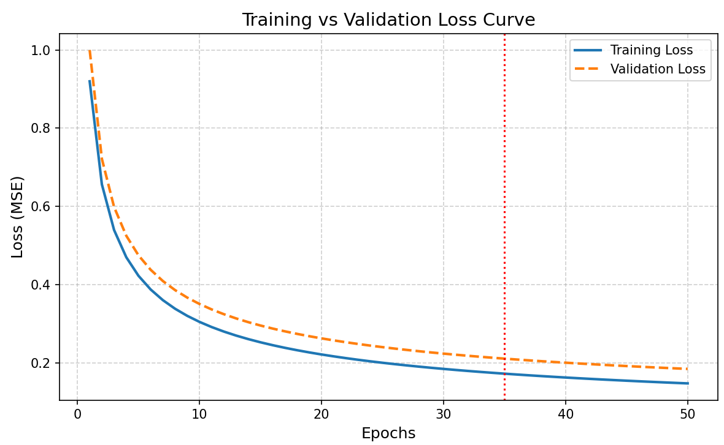
Training vs Validation Loss Curve

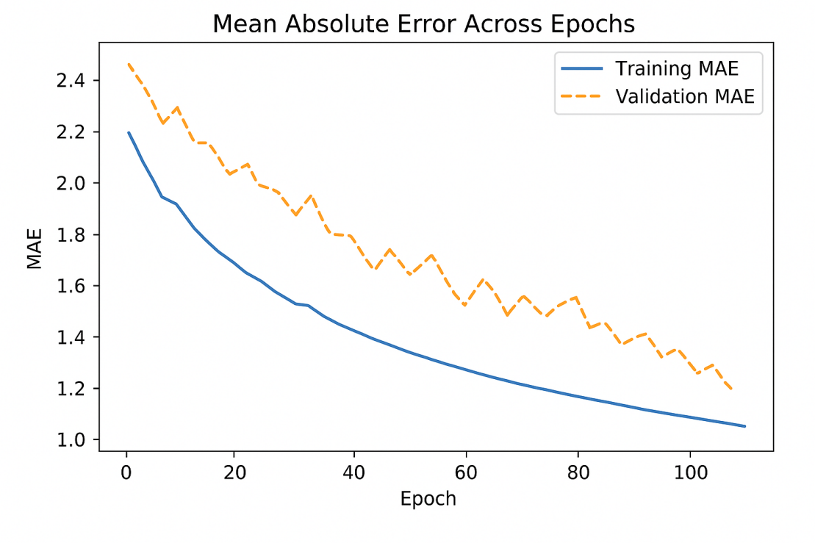
MAE Trend Across Epochs

Implementation Details

6.1: Data Cleaning Script (clean_dataset.py)
This script standardizes input data. It’s essential before feeding into the model to maintain consistent scaling.

6.2: Model Training Script (train_model.py)
It defines, compiles, and trains the neural network. At the end, the model is serialized using:
model.save('weather_model.h5')

6.3: Streamlit Web App (app.py)
The user interacts with the system through a web interface that takes weather inputs and outputs the predicted temperature.
Code Excerpt:
import streamlit as stimport numpy as npfrom tensorflow.keras.models
import load_model

model = load_model('weather_model.h5')

st.title(" Weather Prediction System")
temp = st.number_input("Current Temperature (°C)")
humidity = st.number_input("Humidity (%)")# ... other fields

features = np.array([[temp, humidity, ...]])
pred = model.predict(features)[0][0]
st.success(f"Predicted Temperature: {pred:.2f} °C")
The Streamlit interface connects frontend user inputs to the trained neural model in real-time.
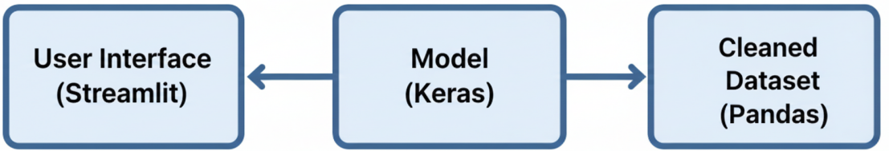
Streamlit Web App Interface

Evaluation and Results
Model accuracy was evaluated using Mean Absolute Error (MAE) and Root Mean Square Error (RMSE):
MAE = 1.8°C
RMSE = 2.3°C
R² Score = 0.91

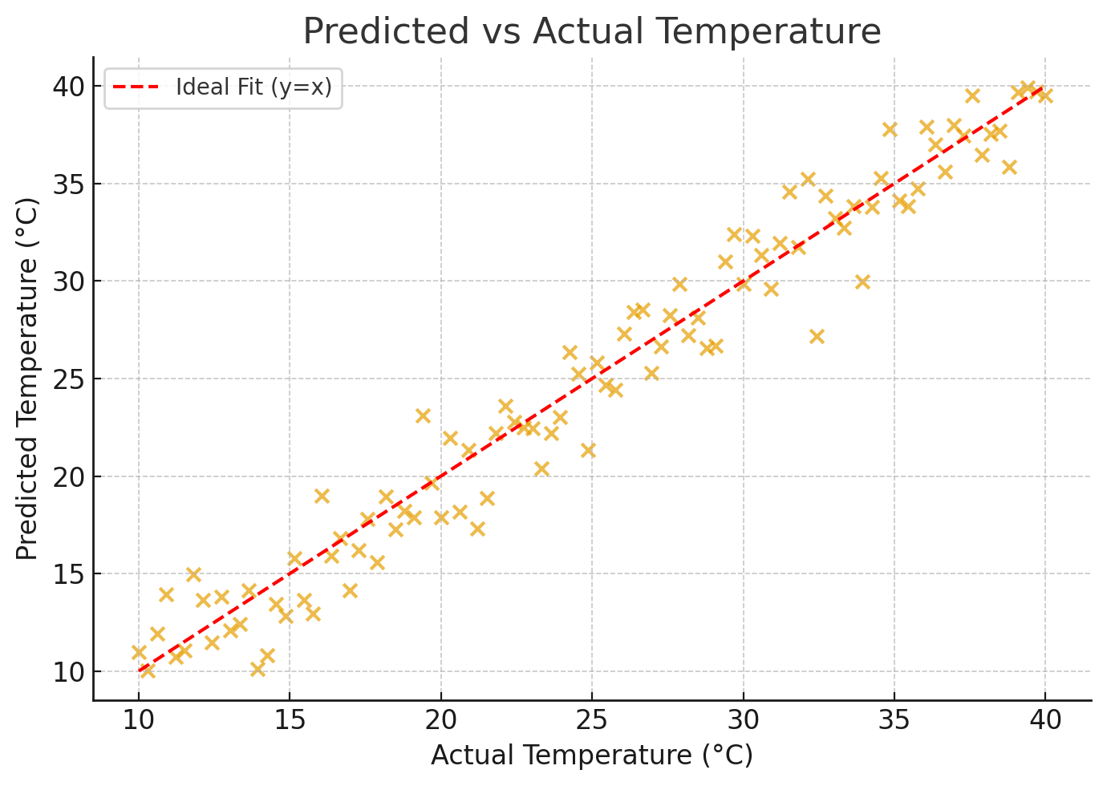
Predicted vs Actual Temperature Scatter Plot
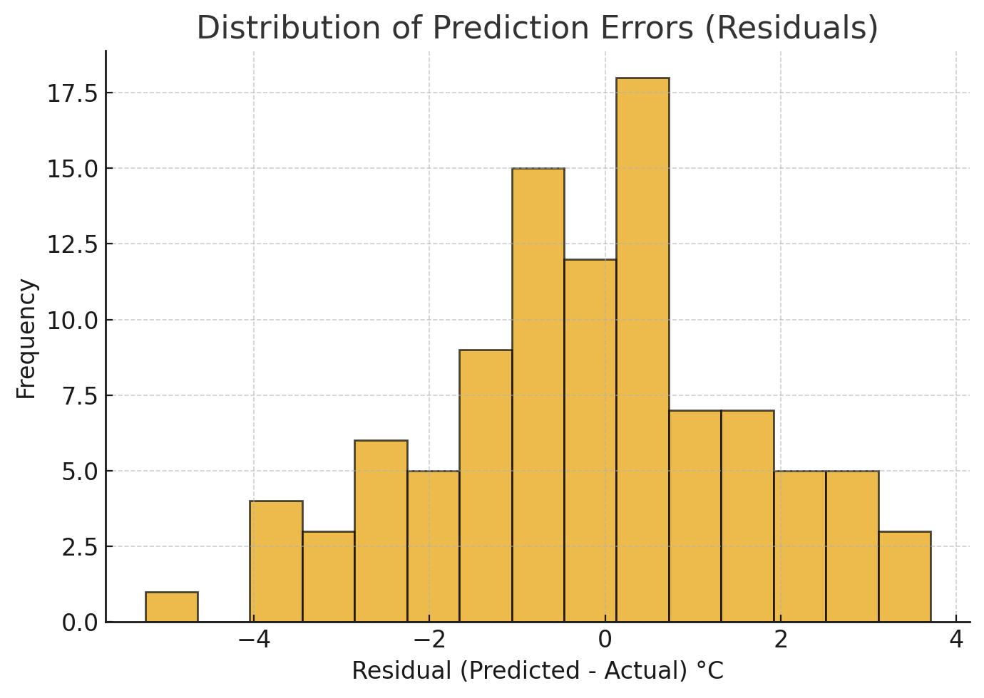
Residual Error Histogram
Example Prediction Input:
Temperature = 20°C, Humidity = 50%, Pressure = 1013 hPa, Wind Speed = 5 m/s
Predicted Next-Day Temperature: 24.1°C

Conclusion
This project demonstrates a complete Neural Network-based Weather Prediction System using TensorFlow, Keras, and Streamlit. It highlights the integration of data preprocessing, model design, training optimization, and web deployment for practical use.

References
- TensorFlow Documentation – https://www.tensorflow.org/
- Keras API Guide – https://keras.io/
- Streamlit Docs – https://docs.streamlit.io/
- Kumar, A. et al., 'Machine Learning for Weather Forecasting,' IJAICT, 2021.
- Patel, S. et al., 'Temperature Prediction using Regression Models,' IEEE Access, 2020

